Exercises: Docker Compose
Exercises for the "Back-End Technologies Basics" course @ SoftUni

Docker Compose Fundamentals (Conceptual)
Docker Compose allows us to define and run multiple services together using a single YAML file. Instead of running containers one by one, we describe:
- what services exist
- how they are connected
- how they are started
Core Concepts
- services: containers that work together (web app, database, worker, etc.)
- networks: isolated communication channels between services
- volumes: persistent storage shared with containers
- depends_on: startup order, not readiness
In Docker Compose:
- containers communicate using service names, not localhost
- configuration is declarative, not procedural

TaskBoard App: Building a Custom Image
In this task and in the other two tasks connected to the TaskBoard app, we will work on the following ASP.NET 8 MVC app with a SQL Server database, provided in the resources:
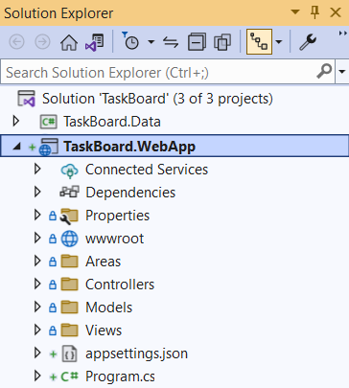
Our task is to create a custom image for this app. Later, we will also publish this image in Docker Hub.

Step 1: Create a Dockerfile in Visual Studio
Our first job is to create a Dockerfile for the app, which will allow us to run it in a Docker container and later connect it to a network. Creating a Dockerfile is easy in Visual Studio, as it is done for you – you should only right-click on the "TaskBoard.WebApp" project and select [Add] [Docker Support…]:
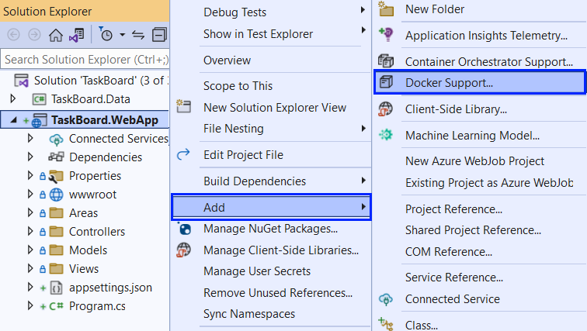
Then, you should choose a target OS for the Dockerfile – choose [Linux], as we are running Linux containers:
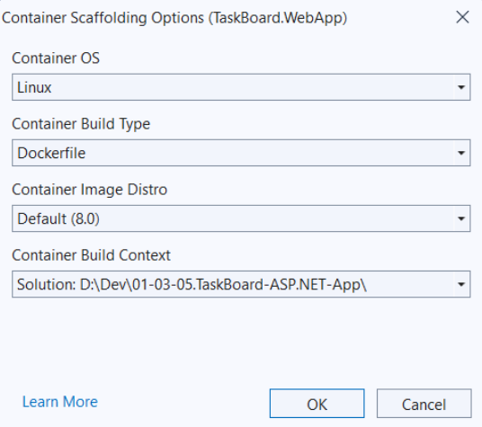
The Dockerfile should be created successfully:
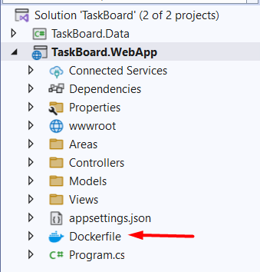
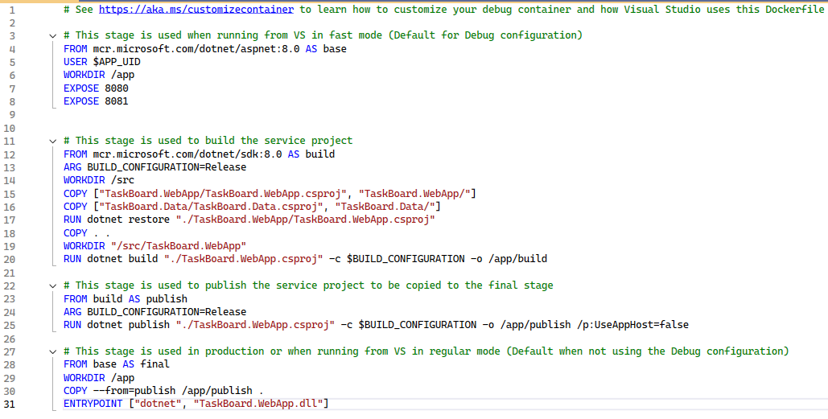
The Dockerfile contains instructions on how an image for the app should be created.

Step 2: Build the TaskBoard Image
Now that the Dockerfile is created, we can build a custom Docker image locally and use it to run containers on our machine.
Open a command-line interface (for example, PowerShell) and navigate to the TaskBoard solution directory, where TaskBoard.sln is located. For Example:
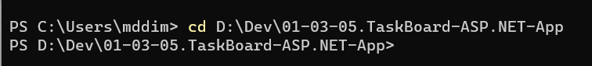
We will now build the image using the Dockerfile generated by Visual Studio, using the following command:
What this command does:
- docker build - Builds a Docker image
- -f TaskBoard.WebApp/Dockerfile - Specifies the path to the Dockerfile
- -t taskboard_webapp - Sets a local image name
- . - Uses the current directory as the build context
Give it some time to build and after the build completes successfully, Verify the Image Was Created.
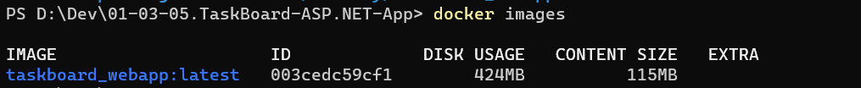
Now keep the image because we will use it in the next TaskBoard app task to run a container. Note that this image is not enough to run you whole app, as it has a database (and it needs a container too).

TaskBoard App: Connect Containers in a Network
In this task, we will run the TaskBoard Web app and SQL Server as two separate containers connected to the same Docker network, so they can communicate using container names.

Step 1: Create a Network
Create a custom network called taskboard_network:
List all networks:
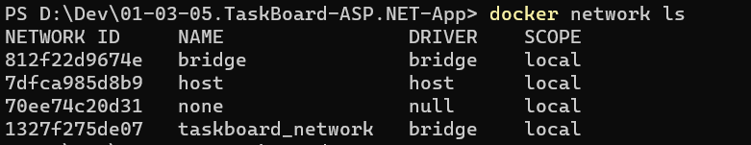
bridge, host, none are Docker’s default networks. They exist even when you do nothing.
taskboard_network is your custom network, successfully created.
DRIVER: bridge is correct.
SCOPE: local is correct.

Step 2: Create and connect a SQL Server Container
Now run SQL Server in the taskboard_network network.
Key options:
docker run - Creates and starts a new container.
-d - Runs the container in the background (detached mode).
--name sqlserver - Gives the container a fixed name (sqlserver).
Other containers will use this name to connect to the database.
--network taskboard_network - Connects the container to the custom Docker network so it can communicate with other containers.
-p 1433:1433 - Maps port 1433 from the container to port 1433 on the host machine.
This allows tools outside Docker (like SQL Server Management Studio) to connect.
-e "ACCEPT_EULA=Y" - Accepts Microsoft’s SQL Server license agreement.
Without this, the container refuses to start.
-e "MSSQL_SA_PASSWORD=yourStrongPassword12#" - Sets the password for the sa (system administrator) database user. SQL Server requires a strong password or it will exit immediately.
-v sqlserver_data:/var/opt/mssql - Attaches a Docker volume to store database files. This keeps the data even if the container is removed.
mcr.microsoft.com/mssql/server:2022-latest - The SQL Server image and version used to create the container.
If the image is not found locally, Docker downloads it automatically.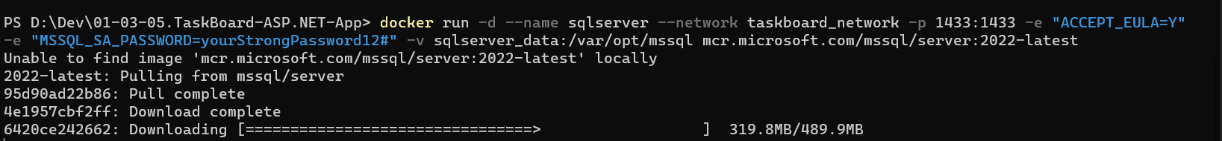

Step 3: Verify SQL Server Container
You know how!
You should see a container named sqlserver in a running state. If it crashes, it’s almost always the password not meeting SQL Server’s absurd requirements, not your fault, just Microsoft.

Step 4: Create and Connect a TaskBoard App Container

4.1. Update the database connection string (appsettings.json)
The TaskBoard app must connect to SQL Server inside the Docker network. In Docker networks, containers do not use localhost to reach each other. They use the container name.
Open the file:
- TaskBoard.WebApp/appsettings.json
Find the connection string and update it so it matches these rules:
- Server: sqlserver (this is the SQL Server container name)
- Database: choose a name (example: TaskBoardDb)
- User Id: sa
- Password: yourStrongPassword12#
- Allow multiple connections: MultipleActiveResultSets=True
Example:
"ConnectionStrings": {
"DefaultConnection": "Server=sqlserver;Database=TaskBoardDb;User Id=sa;Password=yourStrongPassword12#;MultipleActiveResultSets=True;TrustServerCertificate=True;"
}
TrustServerCertificate=True is added to avoid certificate warnings in container environments.

4.2. Build the image again
Because we changed appsettings.json, we must rebuild the Docker image so the container includes the new configuration. From the folder where TaskBoard.sln is located, run:
docker build -f TaskBoard.WebApp/Dockerfile -t taskboard_webapp .
Verify the image exists.
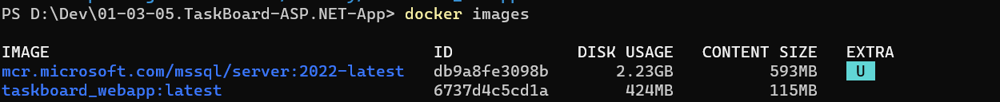

4.3. Run the TaskBoard container in the same network
Now run the web app container and connect it to the same network as SQL Server.
docker run -d --name taskboard_webapp --network taskboard_network -p 5000:8080 taskboard_webapp
What each part does
docker run - Creates and starts a new container from an image.
-d - Runs the container in the background (detached mode), so the terminal remains free.
--name taskboard_webapp - Assigns a fixed name to the container. This makes the container easier to manage and identify.
--network taskboard_network - Connects the container to the custom Docker network. This allows the web app container to communicate with other containers in the same network, such as the SQL Server container.
-p 5000:8080 - Maps port 5000 on the host machine to port 8080 inside the container.
Requests sent to http://localhost:5000 are forwarded to the web application running inside the container.
taskboard_webapp - The Docker image used to create the container.

Step 5: Containers Together

5.1. Check that both containers are running.
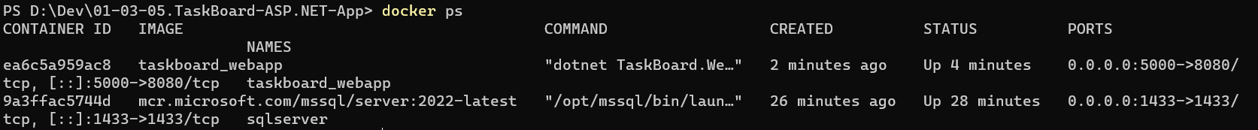

5.2 Inspect the network
Check that both containers are in taskboard_network:
docker network inspect taskboard_network
In the output, look for a Containers section that includes both container names.

5.3. Test in the browser
Open the app: http://localhost:5000
You should see the TaskBoard web app working
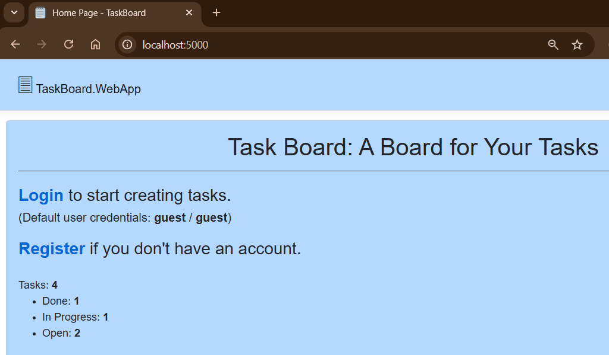

5.4. Prove the database persists
Login with the default user credentials to the app and create a task.
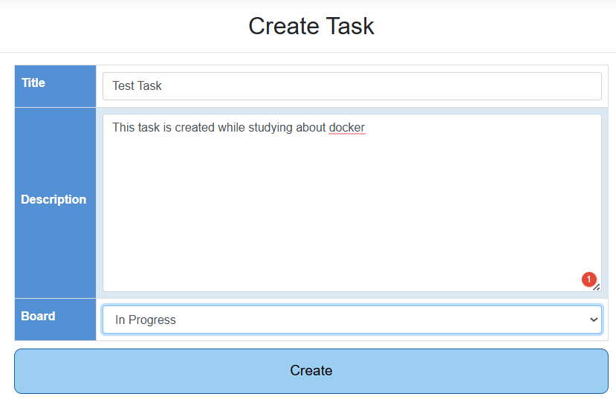
Stop and remove only the web app container:
docker stop taskboard_webapp
docker rm taskboard_webapp
Run it again in the same network:
docker run -d --name taskboard_webapp --network taskboard_network -p 5000:8080 taskboard_webapp
The data should still be there because the database is stored inside SQL Server’s container volume.

Note: In real projects, connection strings are often passed as environment variables instead of being hardcoded in appsettings.json. We will see that approach later in the Docker Compose task.

At this point, we already know how to:
- Build a Docker image for the TaskBoard Web app
- Run two separate containers:
  - one for SQL Server
  - one for the TaskBoard Web app
- Connect them manually using:
  - docker network create
  - docker run commands
This works, but it has clear drawbacks:
- Many long commands that are easy to forget or mistype
- Containers must be started in the correct order
- Recreating the setup later requires repeating all commands
- The setup is not stored anywhere as configuration
This is exactly the problem Docker Compose is designed to solve.

Orchestrating Containers with Docker Compose

Create a docker-compose.yaml File
Navigate to the folder where TaskBoard.sln is located and create a new file named: docker-compose.yaml
This file describes:
- the SQL Server container
- the TaskBoard web application container
- the connection between them
- persistent storage for the database
Paste the following configuration into the file:
services:
sqlserver:
image: mcr.microsoft.com/mssql/server:2022-latest
container_name: taskboard_sqlserver
ports:
- "1433:1433"
environment:
ACCEPT_EULA: "Y"
MSSQL_SA_PASSWORD: "yourStrongPassword12#"
volumes:
- sqlserver_data:/var/opt/mssql
healthcheck:
test: ["CMD-SHELL", "/opt/mssql-tools18/bin/sqlcmd -S localhost -U sa -P $$MSSQL_SA_PASSWORD -Q 'SELECT 1' -C || exit 1"]
interval: 10s
timeout: 5s
retries: 10

web:
build:
context: .
dockerfile: TaskBoard.WebApp/Dockerfile
container_name: taskboard_web
ports:
- "5000:8080"
environment:
ASPNETCORE_ENVIRONMENT: "Development"
ConnectionStrings__DefaultConnection: "Server=sqlserver;Database=TaskBoardDb;User Id=sa;Password=yourStrongPassword12#;MultipleActiveResultSets=True;TrustServerCertificate=True;"
depends_on:
sqlserver:
condition: service_healthy
restart: unless-stopped

volumes:
sqlserver_data:

Explanation of the Compose Configuration
The docker-compose.yaml file defines two services: sqlserver and web.
The sqlserver service runs Microsoft SQL Server 2022. It exposes port 1433 so the database can be accessed from the host machine and uses environment variables to accept the license and set the administrator password. A named volume is used to store database data persistently. A healthcheck ensures that SQL Server is fully ready before other services attempt to connect to it.
The web service builds the TaskBoard web application from its Dockerfile. It exposes the application on port 5000 of the host machine. The database connection string is provided through environment variables and uses the service name sqlserver as the database host, which is resolved automatically by Docker’s internal network. The application is configured to start only after the database service becomes healthy.

Run the Application with Docker Compose
From the folder containing the docker-compose.yaml file, run:
docker compose up -d --build

Verify that both containers are running:
docker compose ps

Open the application in a browser:
http://localhost:5000

To stop the containers, run:
docker compose down

To stop the containers and remove the database data, run:
docker compose down -v

Debug the Web Application in Docker
Even though the TaskBoard web application runs inside a Docker container, it can be debugged using Visual Studio in the same way as a locally running ASP.NET application.
When the container is running, the application process exists inside the container rather than directly on the host machine. Visual Studio can attach to this process and debug it remotely.

Start the Containers
Make sure the application is running:
docker compose up -d --build

Confirm that the taskboard_web container is running before continuing.

Attach the Debugger from Visual Studio
- Open the TaskBoard solution in Visual Studio.
- From the menu, select Debug → Attach to Process.
- In the Connection type dropdown, choose Docker (Linux Container).
- Visual Studio will display the running containers.
- Select the taskboard_web container.
- Attach using Managed (.NET Core) code.
Visual Studio is now connected to the application process inside the container.

Debug the Application
- Set a breakpoint in the application code (for example, in a controller action).
- Open the application in a browser:
http://localhost:5000
- Perform an action that triggers the breakpoint.
When the breakpoint is reached, Visual Studio pauses execution and allows inspection of variables, step-by-step execution, and call stack analysis.

Important Notes
- The application must run in Development environment for debugging to work correctly.
- The container must be running before attaching the debugger.
- If the container is restarted, the debugger must be attached again.

